Spectral coherence: EURUSD and EURGBP
Method 21 / daily log returns / Welch magnitude-squared coherence / Alpari D1 full available history

Study setup
Logical pair: EURUSD , EURGBP
Broker symbols: EURUSD_i , EURGBP_i
Snapshot: 2026-11-03_majors_alpari_D1
Timeframe: D1
Matched return window: 1999-01-06 to 2026-11-02 (UTC bar dates)
Matched return count n: 7183
Dropped unfinished last bar dated 2026-11-03 UTC after a tick-volume check against the prior complete day.
Welch: fs=1.0, nperseg=256, noverlap=128, window=hann, detrend=constant
Headline: gamma^2 nearest f=1/5; also 1/21 and 1/63
Complete matched rows (Excel): EURUSD-EURGBP_Spectral_D1.xlsx
Complete matched rows (HTML table): EURUSD-EURGBP_Spectral_D1_data.html

Method carried forward
Magnitude-squared spectral coherence gamma^2(f) measures shared linear power between matched daily log returns of close, ln(close_t / close_t-1), at each frequency f (cycles per day). Quotes are not inverted. Welch settings are frozen: fs=1, nperseg=256, noverlap=128, window=hann, detrend=constant. Headline is gamma^2 at the frequency bin nearest f=1/5 (five-day cycle from the formula sheet). Also reported: gamma^2 nearest f=1/21 and f=1/63, mean gamma^2 over the frequency grid, and phase of the cross-spectrum at the 1/5 bin. Coherence is unsigned (0 to 1); phase carries timing. Same-sample Pearson r is a side check only. This is not causation and not a trading signal.

Results (headline)
gamma^2 near 1/5: 0.106148
bin f (1/5): 0.199219
phase at 1/5 (rad): -0.294591
gamma^2 near 1/21: 0.274736
gamma^2 near 1/63: 0.244662
mean gamma^2: 0.208524
Pearson r: 0.439899

Target-frequency summary
period | target_f | f_bin | gamma2 | phase_rad
5 | 0.2 | 0.19921875 | 0.10614794 | -0.29459117
21 | 0.04761905 | 0.046875 | 0.27473646 | 0.07976631
63 | 0.01587302 | 0.015625 | 0.24466185 | 0.28770056

Conclusion
Headline gamma^2 near f=1/5 for EURUSD and EURGBP: 0.1061 (bin f=0.199219, phase=-0.2946 rad). At ~1/21: 0.2747; at ~1/63: 0.2447. Mean gamma^2 = 0.2085. Pearson r = 0.4399. This is frequency-domain linkage, not a trading signal.

Charts
Daily closes

Daily log returns

Spectral coherence gamma^2(f)
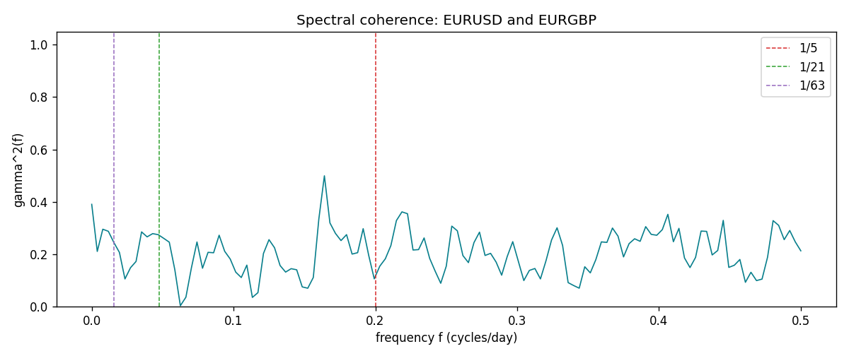

Data report
Matched rows and the coherence sheet are in the sibling Excel workbook named EURUSD-EURGBP_Spectral_D1.xlsx. Embedding all rows as a Word table is impractical; this file holds column summaries and the first and last 15 matched rows.
Columns: time, EURUSD_open, EURGBP_open, EURUSD_high, EURGBP_high, EURUSD_low, EURGBP_low, EURUSD_close, EURGBP_close, EURUSD_tick_volume, EURGBP_tick_volume, EURUSD_spread, EURGBP_spread, EURUSD_real_volume, EURGBP_real_volume, EURUSD_log_return, EURGBP_log_return
Column summaries (matched calculation rows)
column | count | mean | std | min | 25% | 50% | 75% | max
EURUSD_open | 7183 | 1.1815763 | 0.15079461 | 0.8272 | 1.08621 | 1.16623 | 1.29409 | 1.5995
EURGBP_open | 7183 | 0.78698868 | 0.09663692 | 0.5734 | 0.6877 | 0.83389 | 0.86522 | 0.9769
EURUSD_high | 7183 | 1.1867072 | 0.15139096 | 0.8326 | 1.09029 | 1.17134 | 1.29941 | 1.6038
EURGBP_high | 7183 | 0.79006638 | 0.09701205 | 0.5789 | 0.6897 | 0.8369 | 0.8681 | 0.9799
EURUSD_low | 7183 | 1.1765677 | 0.15011491 | 0.8227 | 1.08209 | 1.16259 | 1.288515 | 1.5865
EURGBP_low | 7183 | 0.78428899 | 0.09645396 | 0.5682 | 0.6857 | 0.83166 | 0.86287 | 0.9661
EURUSD_close | 7183 | 1.1816163 | 0.15076829 | 0.8267 | 1.086135 | 1.16619 | 1.2941 | 1.5997
EURGBP_close | 7183 | 0.78703222 | 0.09663758 | 0.5735 | 0.6878 | 0.83395 | 0.86536 | 0.977
EURUSD_tick_volume | 7183 | 103246.15 | 173560.03 | 218 | 9420.5 | 52790 | 99596.5 | 1471626
EURGBP_tick_volume | 7183 | 87133.93 | 145499.42 | 154 | 6594.5 | 44358 | 81413 | 1424684
EURUSD_spread | 7183 | 19.326744 | 16.542159 | 0 | 8 | 12 | 20 | 50
EURGBP_spread | 7183 | 21.324655 | 19.119277 | 0 | 4 | 13 | 40 | 50
EURUSD_real_volume | 7183 | 4.0347326e+10 | 1.669497e+11 | 0 | 0 | 0 | 0 | 3.6149665e+12
EURGBP_real_volume | 7183 | 2.7872287e+10 | 1.3521454e+11 | 0 | 0 | 0 | 0 | 3.5726265e+12
EURUSD_log_return | 7183 | -5.81e-06 | 0.0057996 | -0.03123819 | -0.00324487 | 0 | 0.00325442 | 0.03433183
EURGBP_log_return | 7183 | 2.227e-05 | 0.00487305 | -0.03067367 | -0.00262314 | -9.879e-05 | 0.00256076 | 0.06075387
First 15 matched rows (selected columns)
time | EURUSD_log_return | EURGBP_log_return
1999-01-06 | -0.011547966 | -0.013303338
1999-01-07 | 0.0076280636 | 0.011051402
1999-01-08 | -0.010902799 | -0.004943862
1999-01-11 | -0.007103287 | -0.0012752393
1999-01-12 | 0.0045103728 | 0.0033970309
1999-01-13 | 0.010845346 | 0.00042381861
1999-01-14 | 0 | -0.0019793588
1999-01-15 | -0.010153245 | -0.0076715819
1999-01-18 | 0.0036256946 | 0.00071280921
1999-01-19 | -0.00017235436 | -0.0014261269
1999-01-20 | -0.0031939256 | 0.0019960086
1999-01-21 | 0.0030215416 | -0.00071240297
1999-01-22 | -0.0012075213 | -0.0017118406
1999-01-25 | -0.0030251979 | -0.0054402425
1999-01-26 | 0.00086527651 | -0.00057438255
Last 15 matched rows (selected columns)
time | EURUSD_log_return | EURGBP_log_return
2026-10-13 | 0.0037402957 | 0.00020130374
2026-10-14 | -0.0037582255 | 0.0011241873
2026-10-15 | 0.0056053107 | -0.00087557391
2026-10-16 | 0.0017724895 | -0.0020380844
2026-10-19 | -0.0025394633 | -0.00056950988
2026-10-20 | 0.0023881672 | -0.0035906254
2026-10-21 | -0.00032046717 | -0.00140647
2026-10-22 | -0.0015949606 | -0.0018743924
2026-10-23 | -0.001338521 | 0.00082421033
2026-10-26 | -0.0022706559 | 0.00013133309
2026-10-27 | -0.004152342 | -0.0019957343
2026-10-28 | 0.0022262927 | 0.00066967224
2026-10-29 | 0.0022571351 | -0.0011722209
2026-10-30 | -0.0011458446 | -0.0024205543
2026-11-02 | 0.002120569 | 0.00089940465
First 15 frequency bins
f | gamma2 | phase_rad | period_days
0 | 0.39059045 | 0 | inf
0.00390625 | 0.21071905 | 0.17996606 | 256
0.0078125 | 0.29550004 | 0.29281464 | 128
0.01171875 | 0.28756587 | 0.38963727 | 85.333333
0.015625 | 0.24466185 | 0.28770056 | 64
0.01953125 | 0.20690834 | -0.0438522 | 51.2
0.0234375 | 0.1056395 | 0.44724527 | 42.666667
0.02734375 | 0.14847784 | 0.43225062 | 36.571429
0.03125 | 0.17240158 | 0.37477406 | 32
0.03515625 | 0.2852614 | 0.51037242 | 28.444444
0.0390625 | 0.26633588 | 0.54677961 | 25.6
0.04296875 | 0.27866727 | 0.39031821 | 23.272727
0.046875 | 0.27473646 | 0.07976631 | 21.333333
0.05078125 | 0.26064836 | -0.15305518 | 19.692308
0.0546875 | 0.24605812 | -0.06039541 | 18.285714

